Introduction
This document captures the design for the ASL110 Hand Held Programmer.

Revision History

Date | Revision | Person | Description
July 23, 2019 | A | G. Chopcinski | Created, Added 3 User Menu Choices.

GUI
The size of the Display is 240 x 320 pixels using 8 bit color.
There is an Up and Down button labeled using Up and Down arrows.

User Main Screen
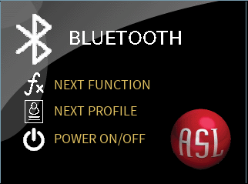
New Background. Smaller ASL “Ball” at lower right.

Initial Programming Screen
This screen is displayed when the unit enter “Programming” which can be accomplished by pressing the Up and Down at the same time for 2 seconds.

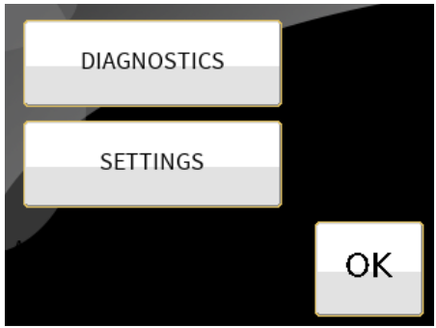

Diagnostic Screen
This screen is displayed when the Diagnostic Button is pressed from the Initial Programming Screen. The left-hand screen is the “Nothing activated” illustration. The right-hand screen shows that all pads are activated.

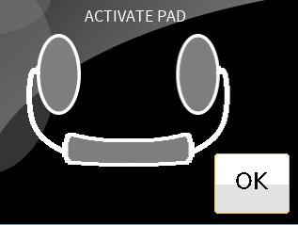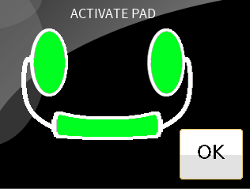

Initial Settings Screen
This left-hand screen is displayed when the Settings button is pressed in the Initial Programming Screen. The right-hand screen is displayed when the USER SETTINGS button is pressed.

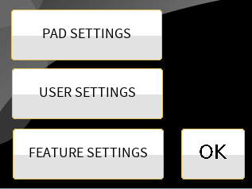

PAD Settings Screen
The left hand is displayed when PAD SETTINGS button is pressed from the Initial Settings screen. The right-hand screen is displayed when the SET PAD DIRECTION button is pressed. Pressing the Arrow button(s) toggles between Left, Right, Forward and OFF.

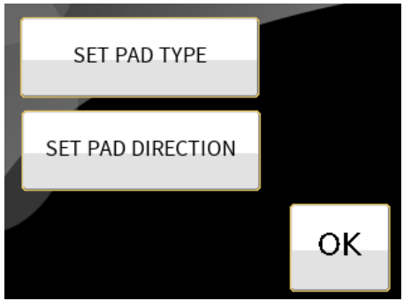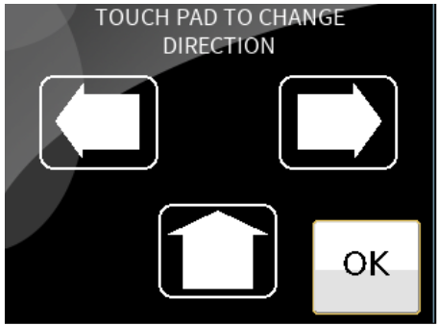

The following screen is displayed when the SET PAD TYPE button is pressed. Each Pad button can be touched to toggle PROP (Proportional) or DIGITAL. The right screen is the first of two calibration screens. The first screen provide the method to set the Minimum threshold for the pad that is illuminated. The second screen provides the method to set the Maximum threshold for the pad that is illuminated.

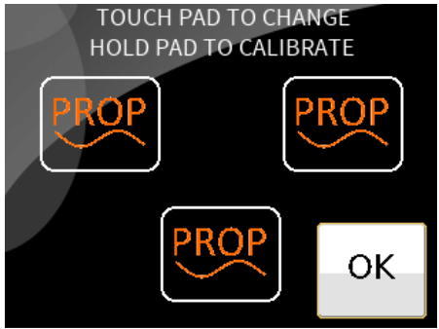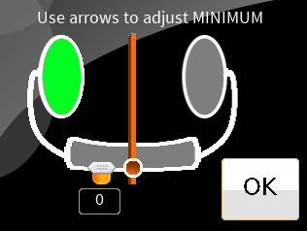

User and Features Settings menu
The following shows the available feature settings on the left and the User Settings on the right. The User Settings control which items are available on the User Screen and, therefore, accessible by the User.

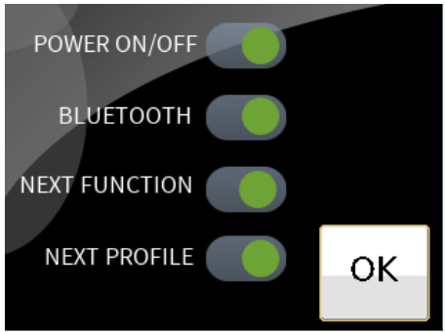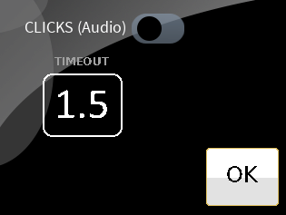

Calibration Procedure
To calibrate a Proportional Head Array, navigate to the SET PAT TYPE screen. Then continuously touch a PAD that indicates PROP. After 2 seconds, the first Calibration Screen appears. Use the Front Panel Up and Down arrows to change the Minimal Value. You can apply pressure to the active pad (as shown, Left) and watch the center slider move in response to the pressure. When the Minimal Value is acceptable, press the OK button to view the Maximum Value set screen. Again, use the Up and Down arrows to adjust the Maximum value. When satisfied, touch OK to complete the calibration procedure.

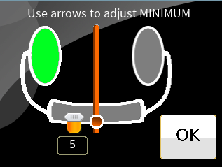
Active PAD is illuminated.
This represents the Minimal Value and changes with Front Panel Up and Down Buttons.
This represents the pressure applied to the active pad.
Minimal Value (0-100)

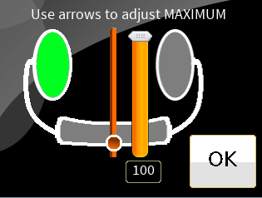
This represents the Maximum Value and changes with the Front Panel Up and Down buttons.
Maximum Value (0-100)

Approvals

Design Engineer | Date
Director | Date
Project Engineer | Date

